Martian Colonization Mission Scoping and Technical Report

Amelia A. Wear

Virginia Aerospace Science and Technology Scholars

MARTIAN COLONIZATION REPORT 2

Martian Colonization Report

The goal of sending a manned mission to another planet has become a top priority for both NASA, and the scientific community of the world. But our ambitions have extended past just visiting; NASA is now looking to organize a manned colonization mission to Mars, effectively starting the expansion of the human race into the universe. The mission would take a crew of people from international sources to Mars, where they would set up a sustainable colony and live for fifty-six months before the return trip. With protection and sustainability in mind, Thermal Protection Systems (TPS) and Reinforced Carbon Carbon (RCC) panels will offer protection from the thermal extremes of space and atmospheric entry. The spaceship and the colony would need to have Environmental Control and Life Support Systems (ECLSS) to keep the crew alive and well throughout the mission. The spaceship will use Solid Rocket Boosters (SRBs) and the space shuttle main engine (SSME) will consist of an interim cryogenic propulsion stage (ICPS) engine during liftoff and directional navigation within low Earth orbit (LEO), but a microwave propulsion system during prolonged space flight. Guidance, Navigation, and Control (GNC) systems such as the orbital maneuvering system (OMS) and the reaction control system (RCS), along with inertial measurement units (IMUs) and an **attitude heading reference system,** will be needed for the mission to be successful. A Mars Oxygen In-Situ Resource Utilization Experiment (MOXIE) will be used for the creation of oxygen for the base. Communications will be conducted with an Optical Payload for Lasercomm Science (OPALS) system. Fibril Boron Nitride Nanotubes (BNNT) will assist in protecting the spacecraft, crew, and colony from radiation.

MARTIAN COLONIZATION REPORT 3

**Mission Scope Summary**

Needs: Establish a human influence within the solar system and to explore the enterprise of the colonization of other planets.

Goals: Send a manned mission to Mars and safely return the crew with information pertinent to Mars and colonization while cooperating with multiple countries and corporations to better international relations and the international space exploration initiative.

Objectives:Fly and land a crew of more than ten people on the surface of Mars. Establish a base that can sustain the crew; this includes life support systems, weather protection, materials manufacturing, and sustaining a biological ecosystem for the sustenance of the crew. Gain data pertaining to the geology, climate, and other aspects of Mars through the use of exploration vehicles and scientific experimentation equipment. Fly the crew in the main spacecraft to the Earth, and return them to the surface safely. During the mission, NASA will work with space programs from other countries and private corporations to develop, and execute the mission, increasing friendly relations with those countries and corporations.

Mission Case: Send a manned mission to Mars, establish a sustainable colony, gather scientific data, and return the crew and data to the Earth safely.

Assumptions:The spacecraft that will transport the rover after Earth orbit escape will be a microwave propulsion system, a new technology that is assumed to be developed and tested by 2020 (Shawyer, n.d.). Technology that will allow the full spacecraft to land on Mars will be available and efficient for use in the mission. Also assumed is the development of efficient technology for the sustainability of the colony, including continuous extraction of water, the creation of fuel for the return trip, and highly effective growth processes for food production. Scientific data collection technology will be more capable by the launch date, allowing for an increased capability to scan and drill into the Martian surface, explore the composition of the Martian atmosphere, and ensure the safety of the base colony and crew from the Martian weather and other environmental risks to the safety of the mission. The rovers that the crew will use for travelling on the surface are assumed to be fuel-efficient enough to carry the crew a fair distance away from the colony and return them safely without running out of an energy source for functioning. The materials manufacturing processes and systems will provide the capacity to quickly and efficiently create new materials and parts for manufacturing.

Mission Users:Mission users will be the global scientific community, especially the countries and corporations that partake in the development of the mission. NASA and such scientists will use the data on the Martian geology and atmosphere to further their knowledge about Mars’s past and prepare for the extension of the preliminary colony to other sectors of the planet. The scientific community will similarly use the data of the Martian geology to create empirical theories about the formation of Mars; with the knowledge of how Mars was formed

MARTIAN COLONIZATION REPORT 4

comes the capability to theorize with increased accuracy the formation of the other planets in our solar system. With the possibility of frozen or liquid water on Mars proven or dispelled, the scientific community would be able to further the model of predicting life, and of predicting the conditions of the geology, of other planets. Furthermore, the private sector will have the ability to better their own exploration and economic ventures to Mars with the data and experience collected from the colonization mission; also, with a permanent settlement on Mars, the establishment of new colonies can be expedited through the use of the established material synthesis equipment of the primary base. Indirectly, the American people would benefit from this mission because of the spinoff technology that would arise from the experience and knowledge gained from the development of the mission.

Authority and Responsibility: The authority over the mission will reside, when ground-based, with a team of international leaders who are cooperating on the mission. They will have the ultimate authority over the project, and a majority or two-thirds vote of the members will decide all decisions – whether decisions will be determined with a majority or two-thirds vote will be determined in the future based upon the amount of organizations participating in the mission. When the spaceship is away from Earth, the mission will be under the command of a mission leader, a crew member on board the spaceship who has been selected by the international mission control board prior to launch. This person will be in charge of making all final decisions, but will be encouraged to refer to mission control for further assistance or updating. Before launch, the responsibility for the mission will lay with the international mission control board, who will be responsible for delegating tasks and communicating for the furthering of the mission. Responsibility for the spaceship and mission in total after liftoff from Earth will be in the hands of the assigned mission leader; further responsibilities for the maintenance of the ship will be delegated among the crew, and responsibility will be assigned to those crew members who are in charge of the fault.

**Restraints**

**Mission Requirements**

* The spacecraft must be able to comfortably house a crew of twenty.
* The spacecraft must house life support systems for both the crew and for the ecosystem.
* The spacecraft must be able to travel to Mars successfully through the use of a microwave propulsion system engine and land on Mars without significant damage or incapacity of the spacecraft or the crew.
* The crew must work together under a commander to maintain order among crew members and the successful operation of the spacecraft and the base modules.
* The base modules must comfortably house twenty crew members and supply them with protection from the Martian weather and solar radiation.
* The colonial base must have a module or location for materials manufacturing.

MARTIAN COLONIZATION REPORT 5

* The colonial base must have a sustainable source of sustenance for the crew.
* The colonial base must be at a location that is relatively safe from the Martian weather.
* The colonial base must house operational rovers for surface travel and exploration.

**System Requirements.** The spaceship must have life support systems which include water coolant loops, heating coils, carbon dioxide control, cabin air loops, pressure controls, ammonia boilers, heat sink systems, electrolysis systems, waste removal systems, and radiator panels. The spacecraft and the colony must have solar panel arrays for supplementary electricity production. The TPS materials of the spacecraft will be RCC covering the front of the craft and around the windows; insulation tiles will provide protection for the rest of the vehicle (*On Orbit*, n.d.). In order to provide nutritious, long-term sustenance, an ecosystem will be housed onboard and in the colony which will be capable continually providing the crew with vegetables and protein. by having a rotating section of the spacecraft as seen in the craft plans below. The spaceship must have SRBs for in-atmosphere navigation, and those boosters must have refueling ports.

The colony must have all of the ECLSS systems that the spaceship has, along with extensive weather protection materials for the exterior of all modules. The Colony must have a communication central, housing modules, an ecosystem, long-distance rovers, and materials manufacturing modules.

***Risks.*** The risks of the manned colonization mission include the loss of the lives of the crew, the loss of the spacecraft and the resources put into the mission, and the loss of information on Mars and how to colonize it.

**Concept of Operations**

**Mission Duration and Phases**

The mission will have a duration of six years; sixteen months will be allotted for travel time between Mars and the Earth, leaving approximately fifty-six months for Martian colonization. Beginning with the completion of the spacecraft, the spacecraft will launch from the Earth’s surface, release fuel stages in the ascent, and use the microwave propulsion system to exit Earth orbit. Then, the spacecraft will begin an eight-month journey to Mars. During the trip, the crew will become accustomed to space travel, conduct scientific experiments pertaining to physics, astronomy, astrology, and other fields of interest, and will become accustomed to sustained living aboard the vessel in preparation for sustained life on Mars. Once the spacecraft arrives at Mars, the spacecraft will enter the Martian atmosphere and land without disengaging any stages. The crew will immediately secure the spacecraft to the Martian surface with guy wires and spikes that will enter the Martian surface and secure the spacecraft against severe weather. The crew will then begin to set up the colony modules, using one of the Mars rovers to carry the modules away from the spacecraft and towards the plateau as seen in

MARTIAN COLONIZATION REPORT 6

the photographs of the landing site. Once all of the modules are in place and anchored with the same procedures as done with the spacecraft, the crew will begin to occupy the modules and organize the colony. The crew will stay on the surface of Mars for fifty-six months conducting scientific experiments and maintaining the sustainability of the colony. One month before the crew’s departure, a replacement crew will arrive; the original crew will, for the next month, prepare the new crew for sustained life and will prepare for their own departure. Fifty-six months after their initial arrival, the original crew will depart from Mars within their own spacecraft, leaving the atmosphere and Martian orbit. The crew will travel for eight months to Earth. Once arrived, the spacecraft will separate from the microwave propulsion system and begin reentry to Earth. The spacecraft will touchdown in an ocean to be determined by the specific timing of the vessel with relation to the Earth upon arrival. This is the termination of the mission. Any residual electronic or physical evidence from the mission will be analyzed and catalogued for further scientific study.

**Operation Timeline**

|  |  |  |
| --- | --- | --- |
| **Time Window** | **Description of Event** | **Constraints** |
| Beginning –  January, 2030 | The spacecraft and the crew of twenty launches off from Earth. Once in the Earth’s atmosphere, the last launch stage of the rocket disengages and the primary engine for the in-transit rocket initiates. The spacecraft leaves Earth’s orbit and begins travelling to Mars. | The spacecraft must be constructed, tested, and approved before January, 2030. The crew must be in peak physical condition at the time of launch. The international mission control board must approve of the projected launch time. |
| September, 2030 | The spacecraft enters the Martian atmosphere and lands on the Martian surface at the designated landing location. The crew begins assembling the base modules. | The Martian weather must be placid enough for a safe landing at the optimal time. The spacecraft must land away from the projected colony base area. |
| September, 2030 – March, 2037 | The crew will establish the sustainable colony, conduct scientific research of Mars, and relay data to ground control. | The crew must set up the ecosystem within two weeks of arrival. |

MARTIAN COLONIZATION REPORT 7

|  |  |  |
| --- | --- | --- |
| March, 2037 – April, 2037 | The original crew will be replaced by at least one new crew from Earth, who will continue to sustain and expand the colony. | The new crew(s) must land away from the base modules. The additional module units must be attached to the original base within two weeks. |
| April, 2037 | The original crew will take off from Mars in the spacecraft that they arrived in, leave the Martian atmosphere, and travel to Earth. | The spacecraft must have enough fuel for the return trip, all of which was synthesized on Mars. The spacecraft must have a new or fully intact heat shield for reentry into the Earth’s atmosphere – before launch from Mars. The crew must have stored enough food reserves on the spacecraft to last at least one month. |
| January, 2038 | The crew will reenter the Earth’s atmosphere and land safely. | The spacecraft must touchdown in an ocean where it will be protected from any and all possible threats due to political tensions. The spacecraft and the crew must be retrieved by the nearest cooperating naval team within five hours of touchdown. The crew must get medical attention immediately after touchdown. |
| Future Years | The colony will continue to expand and become more independent from Earth resupply missions. | --------------------------------- |

**Operations facilities**

A mission control center will be at a new facility built in the United States with the sole purpose of organizing, building, and communicating with colonization missions. This will be where the international mission control board members will meet and make decisions as well.

MARTIAN COLONIZATION REPORT 8

Buildings will consist of modules that are 5 meters in width and 6 meters in length for a room module; all modules will include curved edges and will be based on the Martian surface. Modules will have adjustable legs on the underside to accommodate for an uneven surface. Module types will include five sleeping modules, one common housing module, two laboratory modules, one communications and logistics module, two environmental control and computing system modules, five ecosystem and farming modules, two rover protection modules, one exercise module, and three equipment, food, and tool storage modules. Also, there will be two manufacturing modules wherein Martian resources will be transformed into helpful and valuable materials for expansion and maintenance. In addition to the main module connection hub, an underground emergency room will be created in case of a strong storm or other emergency; this room will be attached to the life support systems above ground. Four solar panels in a circular shape with 10 m diameters will be placed to the right of the main module hub. 200 meters north of the colony will be a landing pad that will be created by packing the regolith in a circle 20 meters in diameter (Herridge). The laboratory modules which will include regolith analyzation equipment, astronomical observation equipment such as a telescope, a combustion chamber, powerful microscopes, and other devices. The Common Housing Module will house the kitchen, along with a chimney for the cooking of chicken and other animal meat.

The communications and logistics module will house the main eating and organizational table and chairs, along with a communications system that will connect with the Mars Reconnaissance Orbiter through the Ka band ("Communications with"). The storage modules will house all excess and reserve food rations and supplies and materials for module maintenance. The systems module will include a MOXIE unit, an electrolysis system, pressure stabilizers, a water creation and recycling system, atmospheric condition stabilizers, heat stabilizers, electricity generators, and general computing systems. The ecosystem modules will house multiple food-bearing plant species, including potatoes, tomatoes, and beans, along with a colony of chickens and roosters which will provide meat and eggs for the colonists. Two rover units will be housed in the rover protection module for excursions for regolith recovery and general exploration of the surface.

The module type of base has been chosen specifically for this mission for multiple reasons. Primarily, the modules can be easily added on to in the future, simply by placing a new module on the surface and connecting it to an existing expansion port on the old module. Using an easy expansion and replacement system facilitates growth and ease of expansion in the future. Furthermore, if the colony were underground, expansion would be extremely difficult within the beginning stages of growth.

**Critical events**

As with any manned mission, the possibility of developing a fault during the mission rises dramatically, especially with the input of human error as a possible source of an issue.

MARTIAN COLONIZATION REPORT 9

However, the main concerns that could possibly arise along the way are stated as follows. Beginning with the spacecraft, should any computational arrays malfunction, an integral system could cause a larger issue within the spacecraft; computational malfunctioning could lead to a loss in communications between the spacecraft and Earth, the malfunctioning of a physical process within the spacecraft, a mathematical or navigational computation, or any of the equipment that is necessary for the success of the colony. If the launch stages do not disengage, the microwave propulsion system cannot effectively initiate, resulting in the necessity for the spacecraft to return to Earth. If, upon travelling to Mars, the spacecraft is damaged in any sort of way, for instance, a micrometeoroid breach, the spacecraft could lose integrity and compromise the mission. Upon entry into the Martian atmosphere, if the heat shield does not remain intact enough for the reentry into the Earth’s atmosphere, the colonists will be required to repair or manufacture a new heat shield with inferior materials, possibly causing the spacecraft to overheat upon Earth-bound reentry. Should the spacecraft land in the wrong location, the colonists will not have the ideal location for survival, leading to the possibility of travelling to the planned location, and raising the possibility of a problem along the journey. If the modules were damaged along the journey, then the crew will be without an essential survival space, immediately decreasing the capability of the crew to successfully sustain the colony or conduct scientific research. Hereupon lies the most dangerous part of the mission: living on Mars. Multiple issues could arise during the fifty-six months that the crew must survive and thrive. For instance, the loss of the rocket, the ecosystem, or any of the crew members severely hinders the crew’s capability to survive and get back to the Earth. Furthermore, should a communications loss occur, the crew will not have a source of information on the global weather, information needed to ensure the safety of the crew and of the spaceship; events happening on the Earth, a vital source of mental security for the crew; and information regarding the mission, information which gives the crew scientific experiments, new tasks, or advice during an issue. Although the arrival of the new crew towards the end of the original mission’s stay on Mars is not imperative for the survival of the original crew, the second mission will provide needed supplies and psychological support for the return trip to Earth. During the return trip, the same critical events listed above for the trip to Mars could occur. During entry into the Earth’s atmosphere, the landing pod could overheat. Furthermore, upon landing in an ocean, the crew will experience extreme forces on their bodies unlike they have been subject to for multiple years; their bodies could be extremely debilitated upon return to the Earth. The success of the mission depends upon the realization and action against these possible critical events.

**Mission Elements**

Propulsion Systems: Propulsion is needed in multiple instances during the excursion. The first, liftoff from Earth, will be attained through the use of the SSME ICPS rocket engine, and SRBs. The ICPS

MARTIAN COLONIZATION REPORT 10

engine will jettison from the spacecraft. These engines have been chosen for their high thrust capability. The use of a microwave propulsion system for liftoff would not create enough immediate thrust to propel the ship past LEO. With the combined use of SRBs and a SSME, the SRBs can retain some solid fuel for emergency situations during flight. The use of microwave propulsion allows for faster travel over a longer flight without hauling the weight that a rocket would use for fuel. Once arrived at Mars, the spacecraft will use some of the fuel contained in the SRBs to change its velocity for orbit entry. Once in the atmosphere, the spacecraft will control its descent with control rockets, thrusters, and SRBs. Finally, the microwave propulsion system will be utilized for the thrust needed for the return trip of the spacecraft.

Guidance Systems

The GNC of the spacecraft includes onboard avionics and position monitoring systems. During initial guidance, and midcourse guidance, three IMUs and an AHRS outfitted with accelerometers, will guide the spacecraft. During the approach to Mars, terminal guidance will be utilized with Mars being the new center for Cartesian coordinate positional calculations (*Space Shuttle*, n.d., p. [Pages 1-5]). All measurement data will be processed through either the DPS or through manual guidance control. Furthermore, the rocket has the capability to receive navigational orders from mission control through OPALS ("NASA Is Laser-focused," 2015).

Life Support Systems: ECLSS are required to keep the cabin not only habitable, but comfortable. To provide for the electrical needs of the spacecraft, an RTG will be housed onboard ("What Are Possible," n.d.). This electricity will provide for the functioning of water coolant loops, heating coils, carbon dioxide control, cabin air loops, pressure controls, ammonia boilers, heat sink systems, electrolysis systems, waste removal systems, and radiator panels are the ECLSS. Extensive insulation, heating sources, and an independent RTG to support the manned mission to the surface of Mars. In order to provide nutritious, long-term sustenance, an ecosystem will be housed onboard which will be capable continually providing the crew with vegetables and protein. This fresh supply of food will lower necessary weight and monotony of packaged foods; similarly, the vegetation will provide a second source of oxygen and carbon dioxide control. The

TPS materials of the spacecraft will be RCC covering the front of the craft and around the windows; insulation tiles will provide protection for the rest of the vehicle (*On Orbit*, n.d.).

Crew Accommodations: Crew accommodations will include an extensive exercise area to ensure their health for the duration of the flight, spacious sleeping quarters, and a common space which includes an electronic gaming station. The exercise station is essential to the maintenance of the bone density of the crew, for without regular physical exercise, the astronauts would not be able to survive on Earth upon their return. Additionally, for the well-being of the mental states of the astronauts, a well-equipped living environment will extend their capability of making decisions and performing crucial tasks to the success of the mission. These amenities will be located in a rotating area upon the roll axis of the ship; in surrounding the cockpit, should an emergency arise, crew members will never be far away from the cockpit and avionics systems. Another reason for having a rotating crew hold is that the creation of artificial gravity prevents bone density loss, and thus preserves the health of the astronauts for the long-duration flight.

MARTIAN COLONIZATION REPORT 11

Landing Systems: Two landings will need to be completed within the duration of the mission. The first is the landing of the spacecraft onto the surface of Mars. Propulsions for this maneuver include control rockets, thrusters, and SRBs. The spacecraft will be held up upon four extended platforms which will be staked and secured in the crust, as well as the SRBs that will be attached onto the lander (Tate, 2012). The platforms will serve the purpose of spreading the weight of the lander across Mars’s surface to protect against cracking of the crust. The second landing includes the return of the spacecraft to Earth. Once in LEO with the assist of the OMS and RCS, all astronauts will assemble in head of the craft; hereupon, this section will separate from the microwave propulsion system and the SRBs. The astronauts, once entering the atmosphere, will perform a splash-down landing in an ocean. This requires multiple parachutes and flotation devices.

Communication Systems: To supply the crew with reliable communication that provides an alternative to communication lags is essential for such an extended flight. For this purpose, OPALS will be used as the primary form of communication to and from the spacecraft. The use of light instead of radio waves creates the possibility of high amounts of information to be sent and received at one time. This makes up for the limit of speedy communication due to communications lags ("NASA Is Laser-focused," 2015).

**Emergency Systems**

Emergency Life Support: During an emergency in transit, the shuttle will have the capability to detach the head of the spacecraft, containing all life support systems, while still being attached to the microwave propulsion system and SRBs; this would provide for all needed systems for a safe return flight to Earth. Should an emergency occur on Mars, the spacecraft is the safe station for the astronauts should the colony and its underground bunker become compromised. Should an emergency occur within Earth’s atmosphere, the astronauts have the capability to eject from the capsule while wearing a floatation suit containing a parachute, emergency food, flares, medical substances, trackers, radios, dyes, and other survival essentials.

Emergency Propulsion: In the case of an emergency wherein any of the propulsion sources of the rocket fail, the rocket will have the capability to jettison this inoperable equipment. After this has been done, the spaceship can use the SRBs for transport to Earth. The ship will hold the systems for specially creating liquid hydrogen and oxygen, siphoning the reactants from the onboard electrolysis chamber, and isolating them away from the ship’s temperature control systems so as to cool them. These materials can provide for a secondary fuel source for the SRB engines in an emergency.

Hereafter are the plans for the spacecraft. The first image is the inner, stationary section, and the second image is the flattened plan of the rotating section that surrounds the stationary section.

MARTIAN COLONIZATION REPORT 12

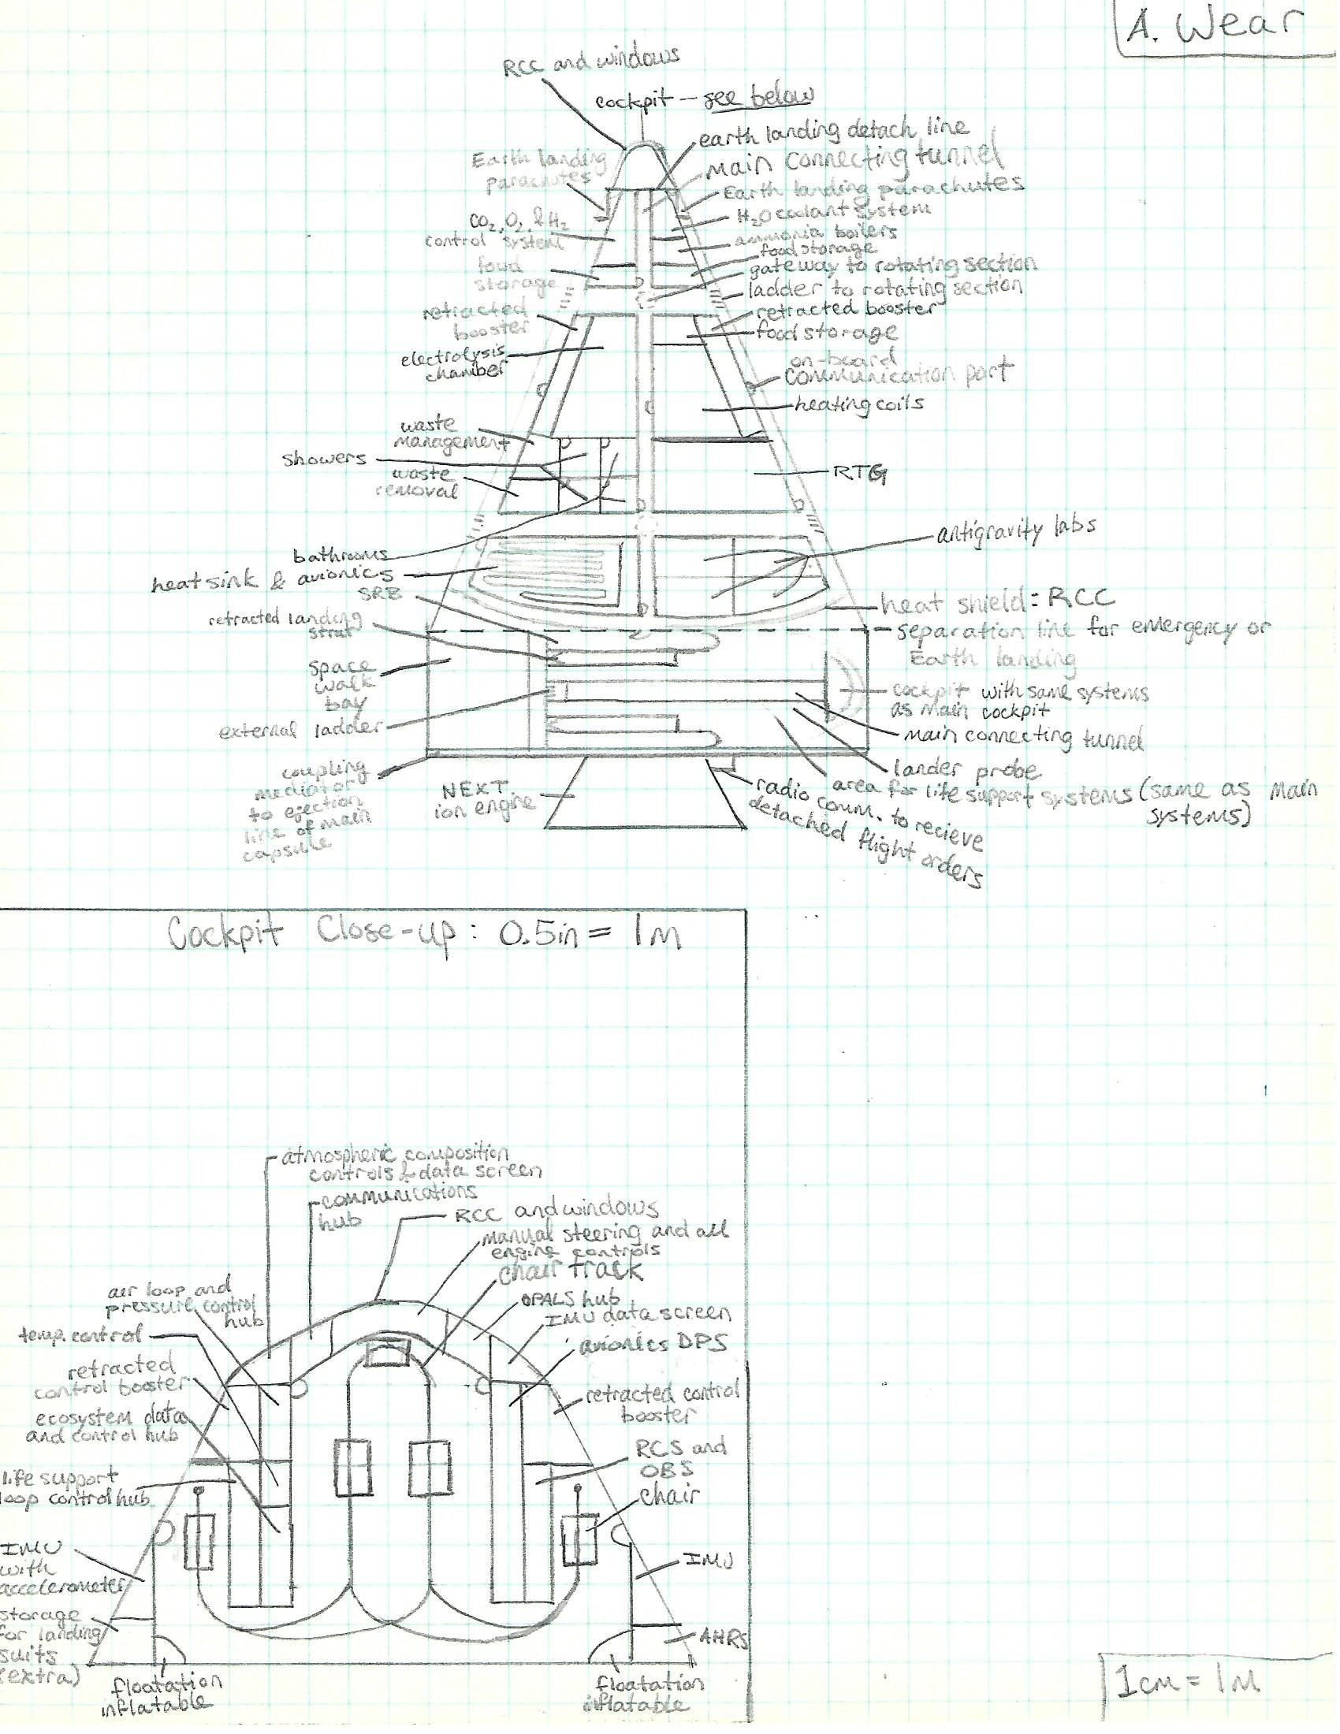

MARTIAN COLONIZATION REPORT 2

MARTIAN COLONIZATION REPORT 13

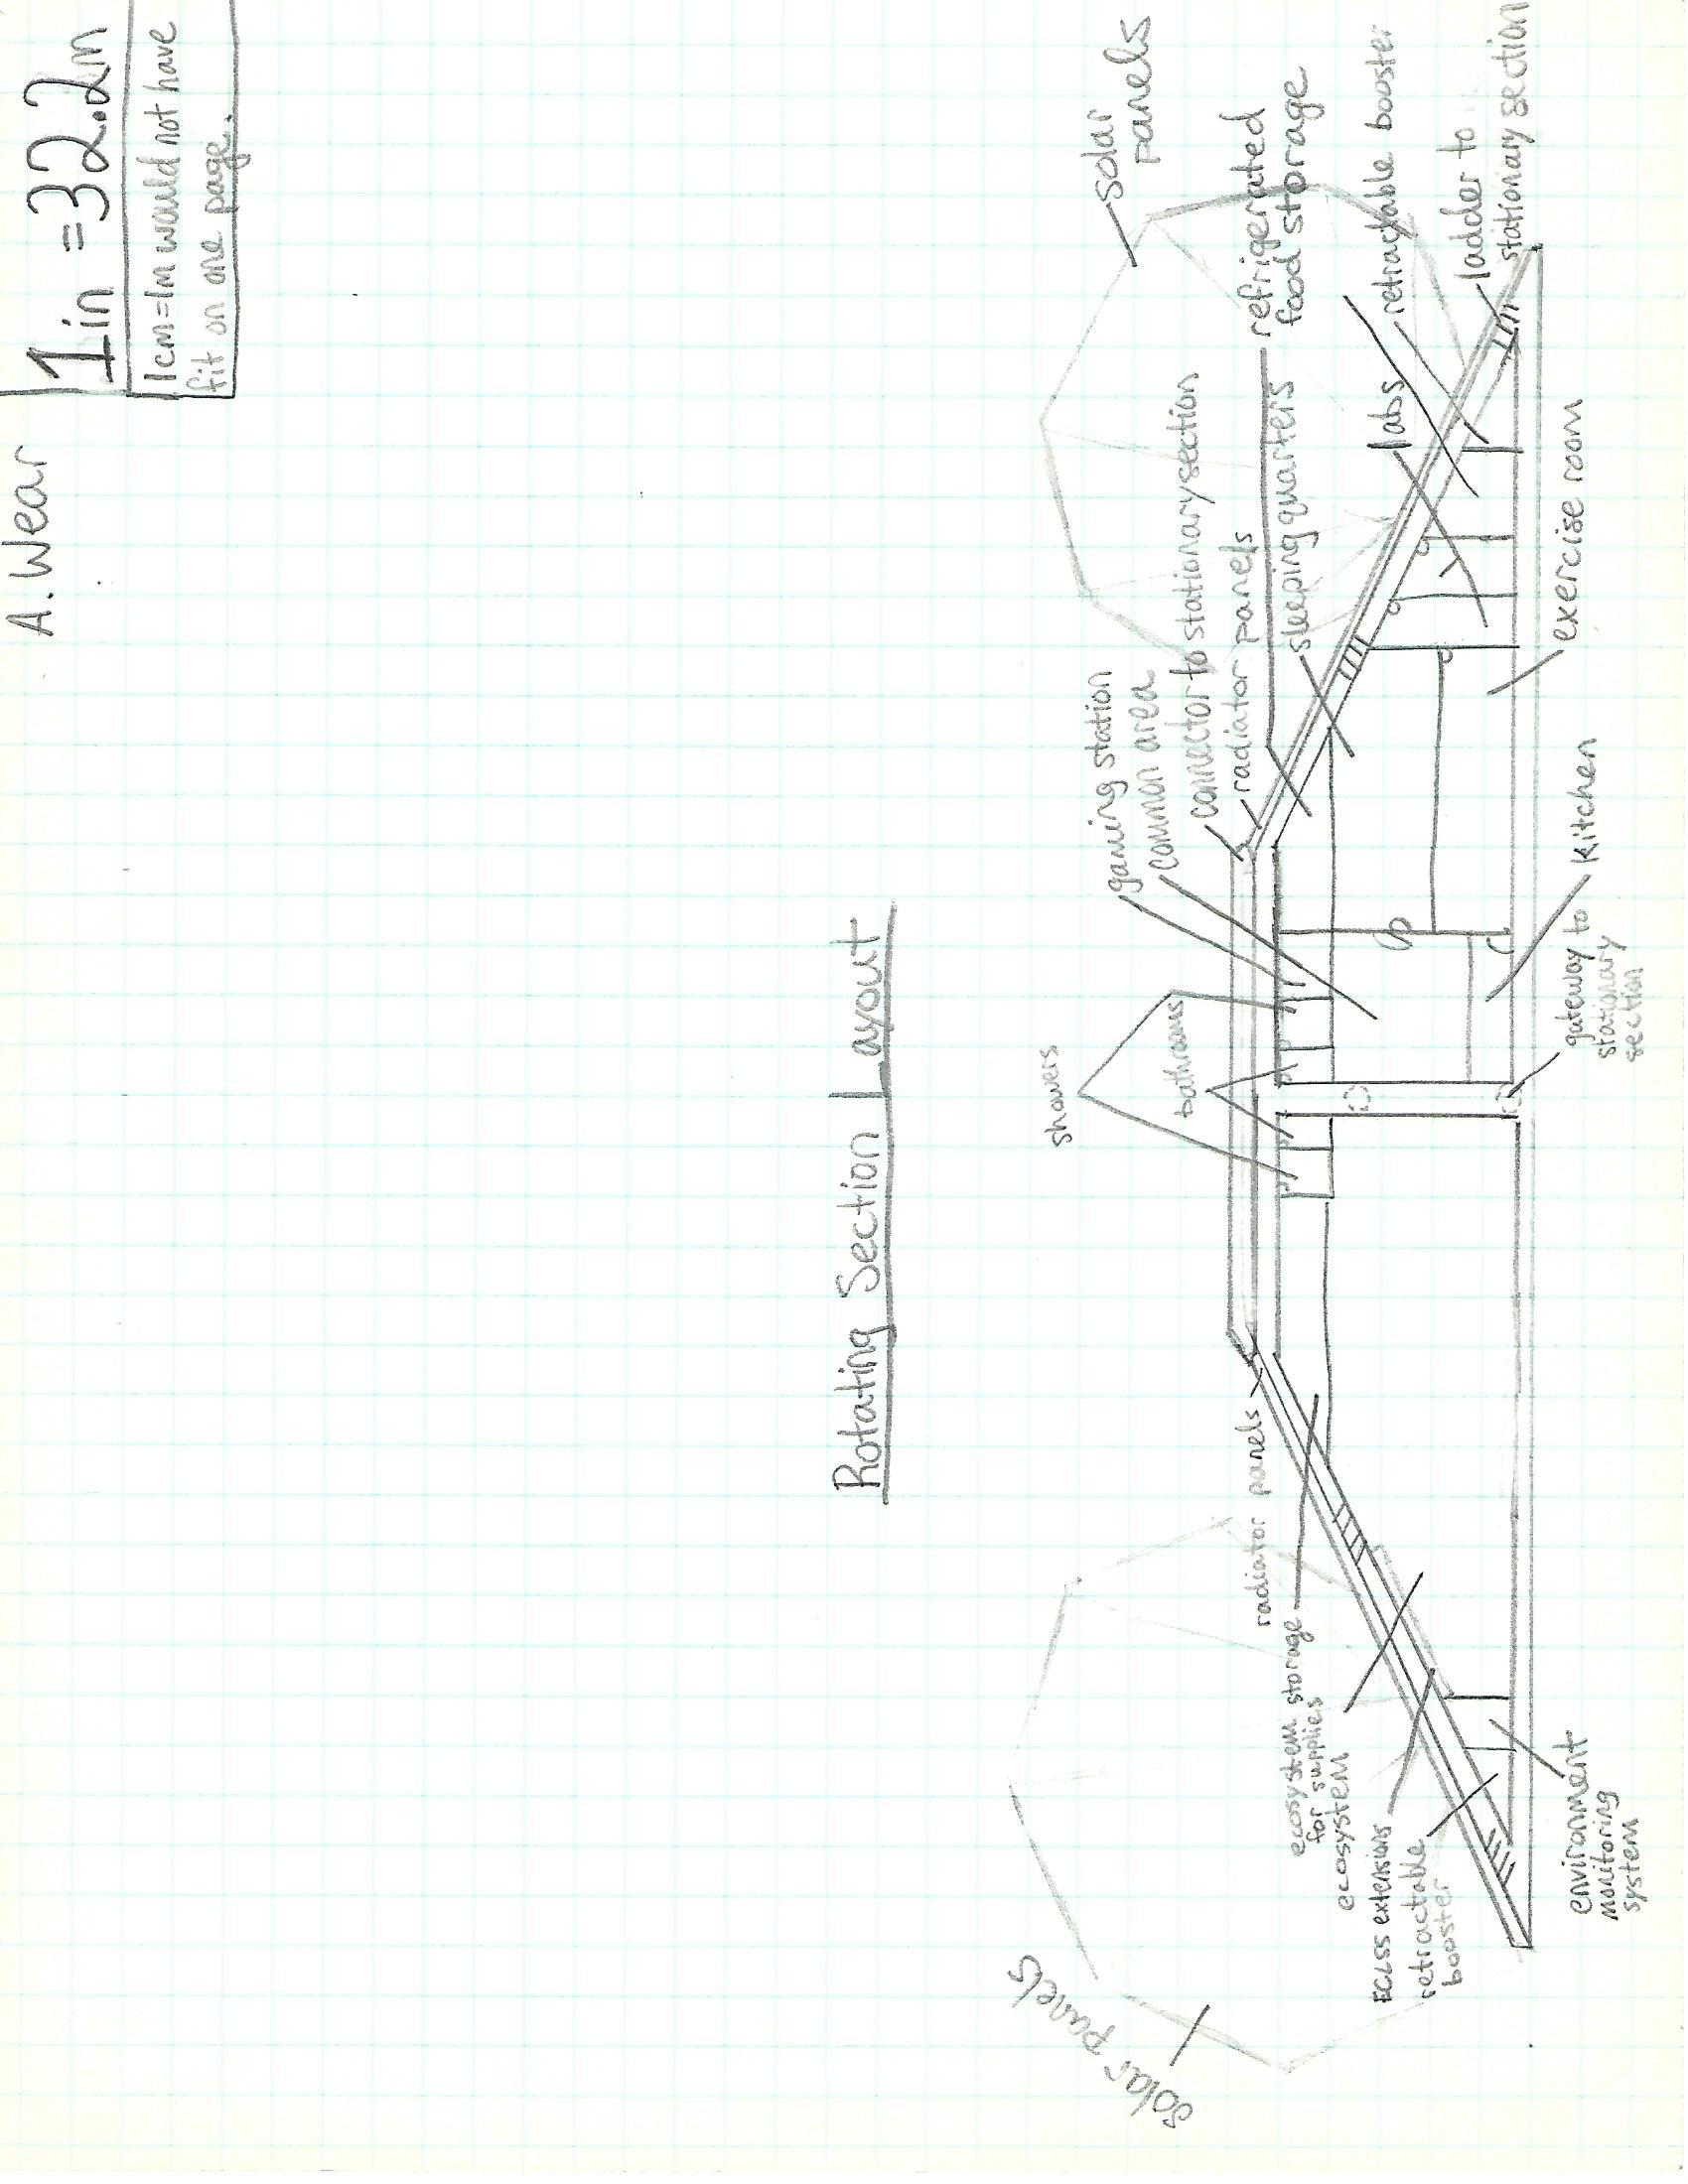

MARTIAN COLONIZATION REPORT 14

**Crew Functions**

The colonization mission will have a crew of twenty members of differing nationalities. The nationalities of the crew members will be determined by the cooperating entities within the mission; there will be a minimum of two candidates from each nationality that are then further tested and chosen for capability and quality. The mission will need people who have qualities of leadership, cooperation, communication readiness, capability to operate clearly under pressure, and the capability to follow instructions and commands. The skills that the crew will specifically need to have will be farming, scientific processing, leading, communicating, healing, fixing machines, coding, cooking, driving the rovers and spacecraft, and chemical processing. Half of the crew will be male and the other half will be female; having equal gender representation will lead to a more balanced and reasonable environment for crew operation while also giving the crew the opportunity to get used to the eventual colony dynamic of having two genders around. The ages of the crew will be between thirty and thirty-five at the time of the mission launch. The ages of the crew will be within this range so they will be within the peak of their physical fitness, yet old enough to be mature and to know how to cooperate with others in a highly-stressed environment. Furthermore, the age range is purposely old enough to have completed flight hours and education on space flight in schooling, a requirement for the entirety of the crew, for they all need to know how to fly the spacecraft in an emergency.

There will be a mission captain who will be in charge of overall operations after liftoff from Earth; this person will be able to decide actions for the spacecraft and the colony. The mission captain can be overturned on his decisions by the majority vote of the rest of the crew or an order from Mission Control on Earth. Although the crew will be specialized for a specific action, duties and activities will rotate among the crew to keep the mental states of the crew members at a high activity level. There will be five people specialized in botany and ecological systems for the sustenance of the ecosystem and the living creatures on the spacecraft and in the colony. These people will be trained also in cooking and food preparation. There will be five people specialized in the workings of the spacecraft, the rovers, and all mechanical aspects of the mission with the sole purpose to operate and maintain and possible expand upon the mechanical operations of the mission. These people and two more will also be specially trained in coding and computer systems for recreating or expanding on programs. The maintenance of an operational status of the spacecraft and the colony will be crucial for mission success. Five people will be trained in scientific research procedures and long-distance rover driving techniques. These people will be in charge of scientific research and data collection. The five remaining people, including the mission captain, will be trained in leadership, and will be charged with the specialized knowledge of all of the positions of the crew members, with the task of completing temporary tasks and filling in where assistance is needed. They will also be in charge of communications, data relays, and base safety. These specializations and the

MARTIAN COLONIZATION REPORT 15

knowledge thereof will be rotated, with specific job assigning left to the leadership crew. This rotational system will maintain productivity and psychological health within the colony.

**Outpost Location**

The colony will be situated within a shallow canyon to the right of Aeolis Mensae; the coordinates are 142.12, -2.79 ("NASA's Mars"). The colony sits at the bottom of a small hill within the valley; both the shallow canyon, and the hill will serve to protect the colony from strong winds. Wind being directed through the canyon, directed towards the north, will be parted by the small hill, creating a protective pocket of air for the colony. Should winds come into the mouth of the canyon heading south, the shallowness of the canyon and the buffering capability of the small hill will decrease the speed and damaging impact of the wind upon the colony. Furthermore, the colony will be within what appears to be a dried-up riverbed; this creates an increased opportunity to study, and possibly find evidence of previous life and liquid water. that existed on Mars. The position of the colony within the canyon will not hinder the access of sunlight due to the shallow canyon walls.

Environmental conditions will include: 62.5% less gravity ("MARS FACTS"), a near vacuum, Mars regolith traveling at high velocities, solar winds and radiation, temperature extremes, and a differing sunlight cycle than that of the Earth. To adapt to the lesser gravity, all modules and eventual buildings will be anchored into the ground with stakes to ensure their stability. Rounded surfaces made of scratch-resistant plastic will serve to protect the colony modules rom direct impacts from air-borne regolith, thus elongating the lifespan of the colonial modules. The near vacuum will be addressed through sealing the buildings, and creating a pressurized environment within all life-form habitation zones; separate pressurized entrance chambers will ensure the stability of the pressure within the rest of the colony. Solar wind and radiation will be addressed through the use of protective materials such as BNNT and polyethylene (Frazier). Temperature extremes that range from minus seventy to 6 degrees Celsius around the longitude that the colony will be situated, as found by NASA’s Curiosity ("Weather On Mars"). In order to maintain a habitable temperature within the colony’s modules, regulatory heating systems will be utilized for control. Furthermore, winds will blow regolith so that it will enclose the modules over time. This regolith will serve as an insulating and radiation protection layer, without having to completely bury the colony. To adjust to the differing day and night cycles, wherein Mars has a 24 hour and 37-minute day in comparison to a 23 hour and 56-minute day on Earth, colonists will elongate their sleeping period so that they maintain the same schedule of waking and sleeping periods per the sun’s position.

The location of the colony is indicated on the images below by a white oval. The images progressively zoom in on the projected colonization location.

MARTIAN COLONIZATION REPORT 16

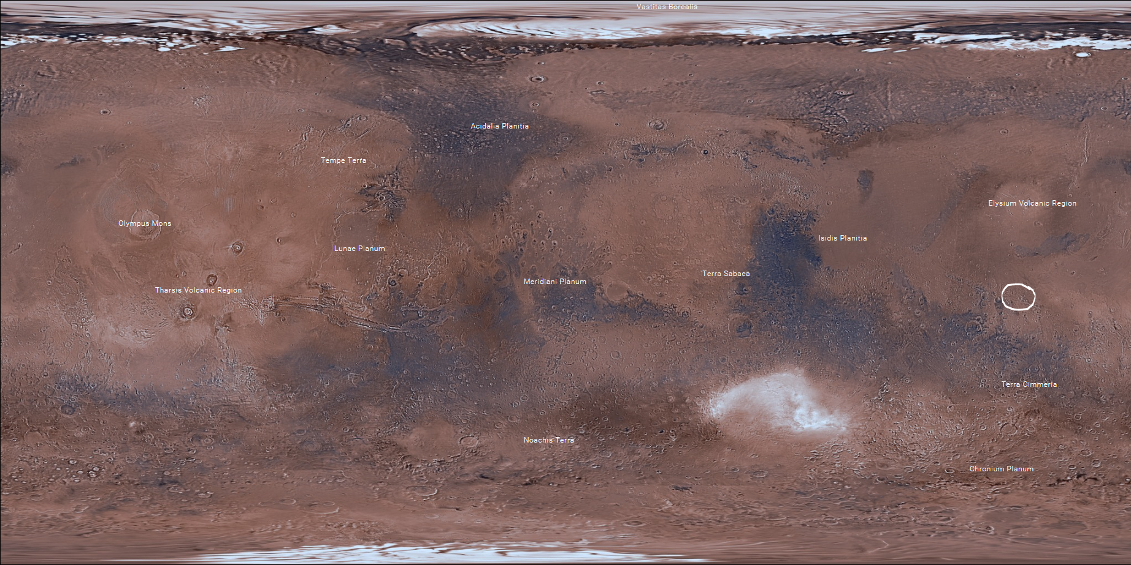

MARTIAN COLONIZATION REPORT 17

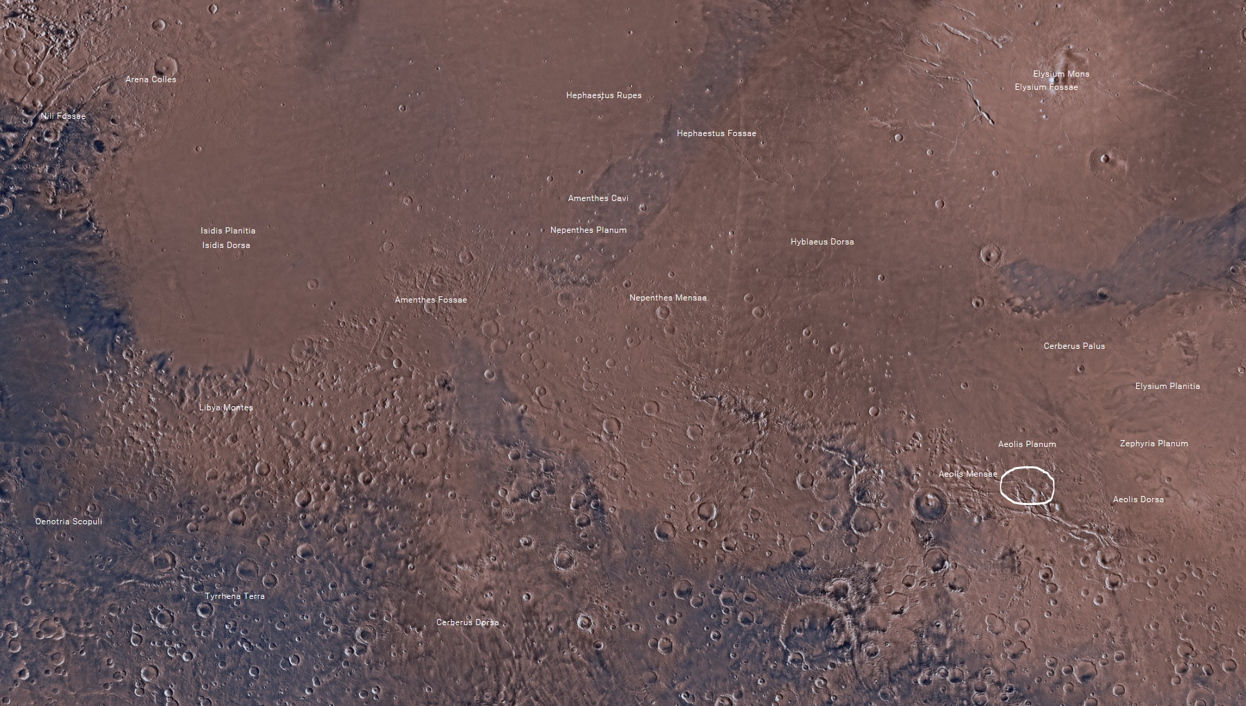

MARTIAN COLONIZATION REPORT 18

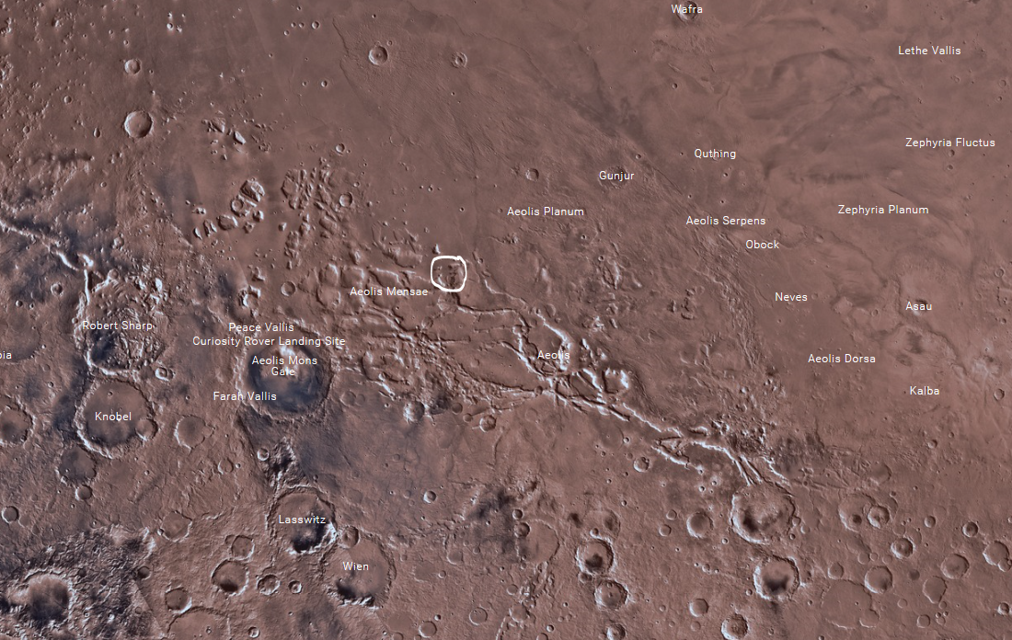

MARTIAN COLONIZATION REPORT 19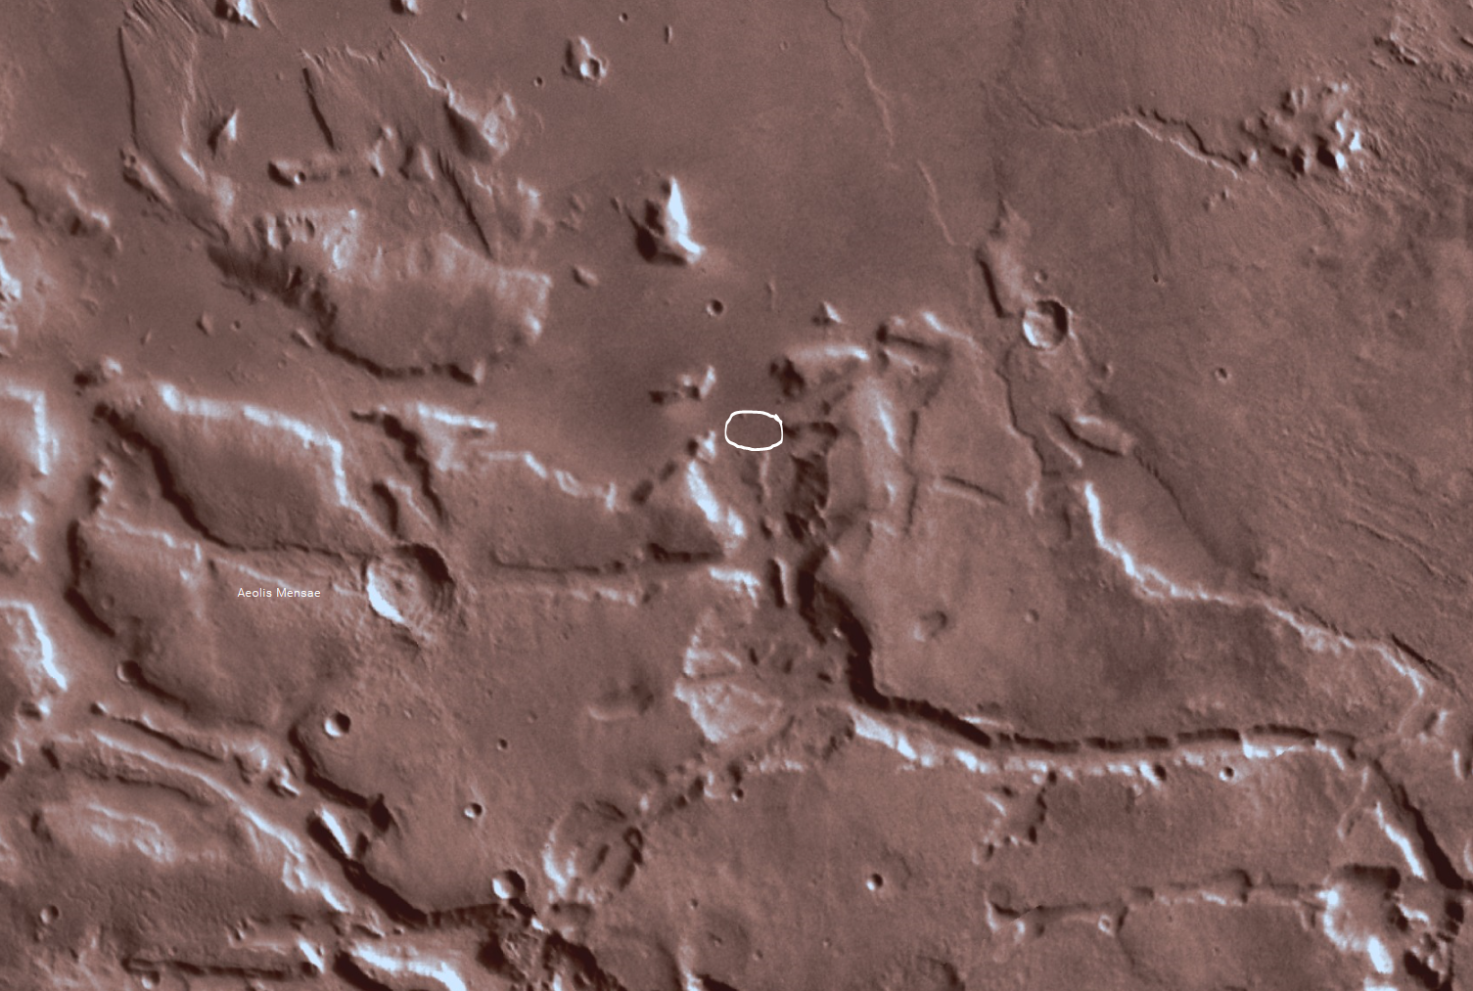

MARTIAN COLONIZATION REPORT 20

**mission statement.** Sending a manned mission to Mars and establishing a sustainable colony is crucial because of the mission will lead to improved international relations and cooperation, releasing some current international tensions; the security of the safety and economic and scientific payoffs of interstellar colonization, leading to further exploration and expansion; and improved technology for use on Earth, greatly raising the technological capability of the world, and even of the private sector in spinoff technologies.

**Base name and reasoning**

The colonization base will be named Salustatia after the Roman goddess of good health (Atsma, 2000). As the base will be the first of its kind, the base will be named for good health as a blessing and projection for the success; furthermore, the connection to Rome creates a feeling of nobility and empirical knowledge, a great feeling to generate for publicity and the support of the public. Furthermore, the use of a Roman god continues the trend of using Roman gods in reference to the planet, seeing as Mars is the Roman god of war (Cartwright, 2014).

**Conclusion**

The expansion of the human race into the solar system has been the dream of the Twenty-First century, and will be the dream of generations to come. Planning a manned mission to Mars would be the first step in achieving this dream. This mission will be planned by an international team of nations and corporations alike. Starting in 2030, a six-year mission with a crew of twenty highly trained international representatives would work to establish a sustainable colony - named Salustatia - on the surface of Mars. Multiple life support systems and colony modules will be needed for the health and safety of the crew. Although the risks and the possibility of failure is ever-present, new technology in the future will provide the international scientific community with the opportunity to address these issues. The data, knowledge, and experience that a manned mission would retrieve is nothing when compared to the prospect of establishing a permanent habitation on the surface of another planet, and subsequently beginning the era of human exploration of and expansion into the universe.

MARTIAN COLONIZATION REPORT 21

References

Atsma, A. J. (2000). [HYGEIA]. Retrieved April 11, 2017, from http://www.theoi.com/Ouranios/AsklepiasHygeia.html

Cartwright, M. (2014, January 16). [Mars]. Retrieved April 12, 2017, from http://www.ancient.eu/Mars/

Communications with Earth. (n.d.). Retrieved April 14, 2017, from https://mars.nasa.gov/mro/mission/communications/

Forrest, J. (n.d.). *The Space Shuttle Challenger Disaster A failure in decision support system and human factors management*. Retrieved from http://dssresources.com/cases/spaceshuttlechallenger/index.html

Herridge, L. (2015, May 29). New Small Class Vehicle Launch Pad Takes Shape at Launch Pad 39B. Retrieved April 14, 2017, from https://www.nasa.gov/feature/new-small-class-vehicle-launch-pad-takes-shape-at-launch-pad-39b

Mars Facts. (n.d.). Retrieved April 14, 2017, from https://mars.nasa.gov/allaboutmars/facts/#?c=inspace&s=distance

[Martian Flag]. (2004). Retrieved from https://astrosociety.org/edu/publications/tnl/66/flag.html

[NASA]. (n.d.). Retrieved from https://www.brandsoftheworld.com/logo/nasa-1

NASA is Laser-focused on Deep Space Communication. (2015, August 24). Retrieved December 28, 2016, from https://www.nasa.gov/mission_pages/station/research/news/comm_delay_assessment

MARTIAN COLONIZATION REPORT 22

NASA's Mars map [Map]. (n.d.). Retrieved from http://mars.nasa.gov/maps/explore-mars-map/fullscreen/

[](https://www.google.com/url?sa=i&rct=j&q=&esrc=s&source=images&cd=&cad=rja&uact=8&ved=0ahUKEwiMsoCQ8KHTAhVE5IMKHWPnDkIQjRwIBw&url=https://www.brandsoftheworld.com/logo/nasa-1&psig=AFQjCNGsb-CeI6Xe9fceuW_0ji3dnnRcSA&ust=1492188111418052)

New Martian Colonization Mission!

The expansion of the human race into the universe has been a dream for the past century, but now the idea is becoming reality! Sending people to other planets for research purposes is being surpassed by the increasing desire for the colonization of those planets. Currently, NASA is planning an international colonization mission to Mars, looking to establish the first permanent extension of the human race past the Earth!

The colonization mission will last for six years, giving the crew of twenty women and men from around the world adequate time for establishing a sustainable colony and even manufacturing new products and materials for further surface expansion. The crew will conduct scientific experiments on the Martian atmosphere and geology, gathering more data than ever before on Mars. New data, especially first person accounts, will undoubtedly lead to developments in theories about the formation of Mars and whether it has supported life or not!

The feat of sending humans to Mars and returning them safely will require, and therefore develop revolutionary technology such as a microwave propulsion system and a rotating spacecraft section for artificial gravity production. Furthermore, new and improved technologies will be developed due to innovative solutions to the various challenges of the mission. These improvements will then be brought into the commercial world, ultimately improving the quality of life on Earth.

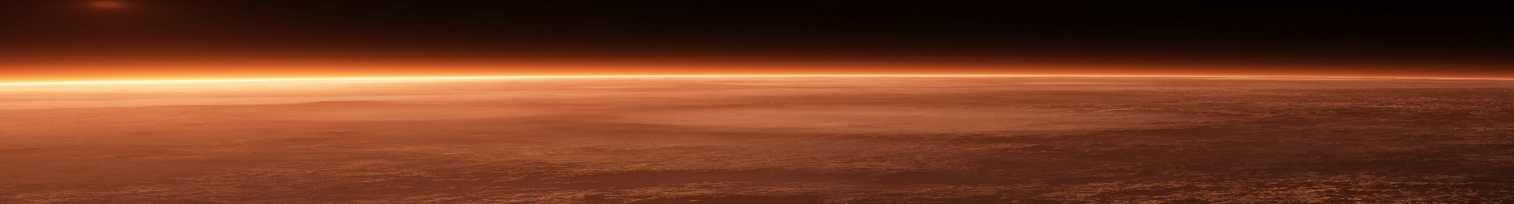 Although the danger and risks the come with sending any manned mission to space are high, the colonization of Mars will prove to be the first step towards the safe and cost-effective expansion of the human race into the solar system. Future ventures to Mars and beyond will become more efficient for both nations and for corporate enterprises. The first colonization mission will open new doors to both the expansion of man into the universe and the improvement of human life, wherever it may go.